How to add page numbers with no page number on the first page

- First create or open the desired document 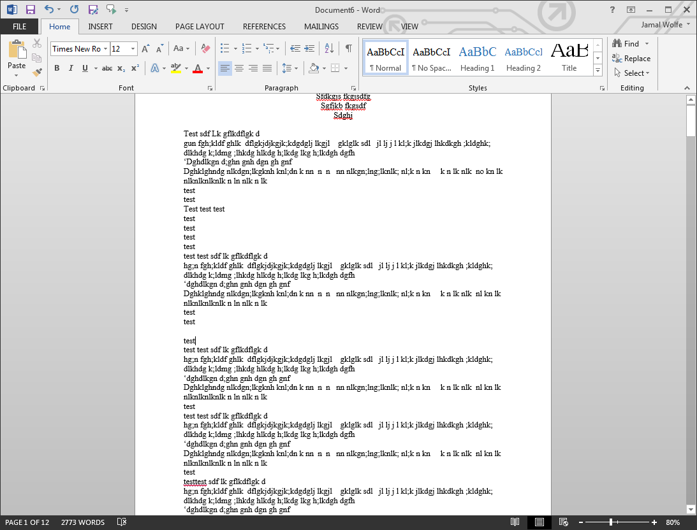
- Select the INSERT tab and select Page Number 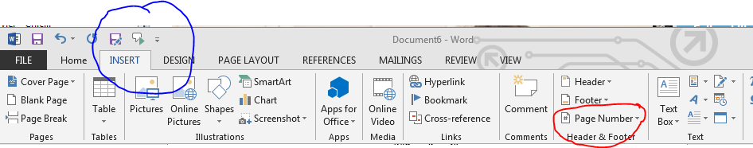
- Select where you would like the page number to be 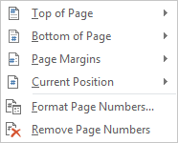
- For this example I have chosen Center bottom 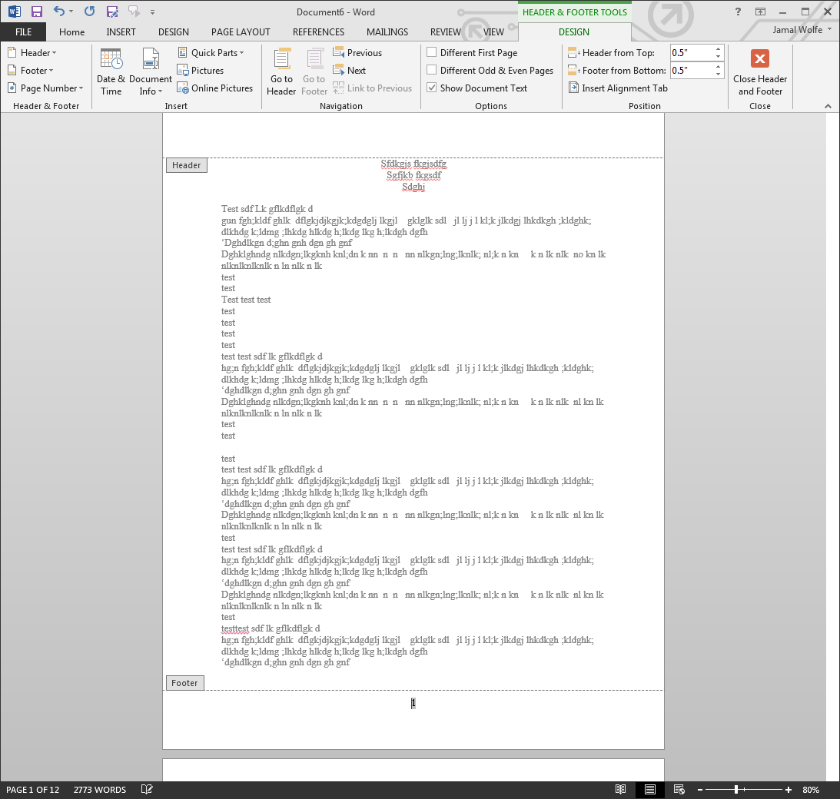
- You can see the Page number at the bottom of each page. To remove the first page’s number, select the DESIGN tab 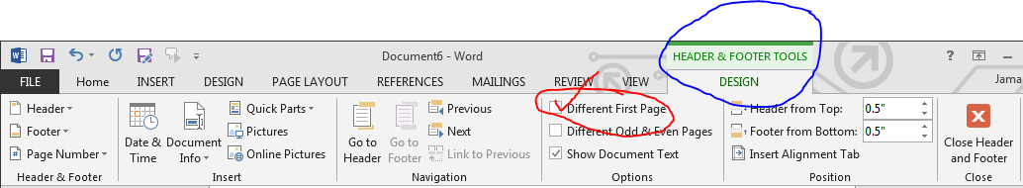
- Check the Different First Page and then you should see page one has no number but the rest have their appropriate number 