Internet browsers such as Mozilla Firefox, Internet Explorer and Google Chrome are preloaded with default homepages, which appear upon launching your web browser.
In most cases, the homepage is already set to Google or Bing, two leading search engines.
If your homepage is not preset to Google, you can make it your homepage by going to the browser's settings options.

__________________________________________________________

How to make Google.com your homepage using Mozilla Firefox

In Mozilla Firefox, click the "Tools" menu from the menu bar at the top of the homepage.
Under the "Tools" menu, select "Options".
On the options screen, select "General" from the menu options along the top of the screen. Within the "General" screen next to "Home Page," enter "https://www.google.com" to set Google as your homepage.

How to make Google your homepage using Google Chrome
- To make Google your default homepage in Google Chrome, click on the menu icon represented by three lines on the top right corner of the screen next to the Web address input field.
- Choose "Settings" from the drop-down options.

- In the "Settings" screen, check the box labeled "Show Home button". Once the box is checked, click "Change" and change the address to. "https://www.google.com"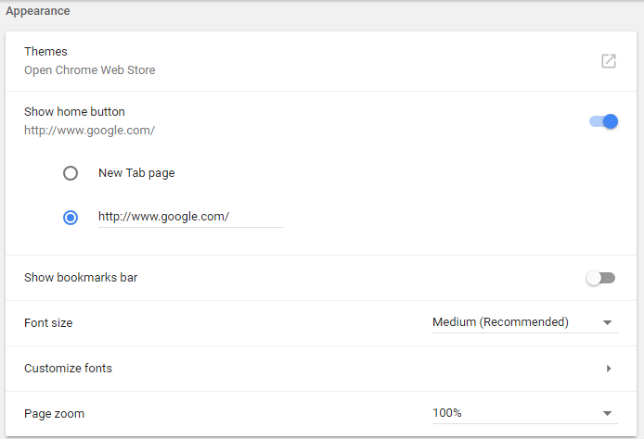
Internet Explorer users can set their homepage to Google in similar fashion to users of Mozilla Firefox.
On the menu bar at the top of your browser's homepage, click the "Tools" menu. Under the "Tools" menu, select "Internet Options".
On the options screen, select "General" from the menu tabs along the top of the screen.
Within the "General" screen, you will see a text box under the heading "Home Page". Inside the text box, type "https://www.google.com".

